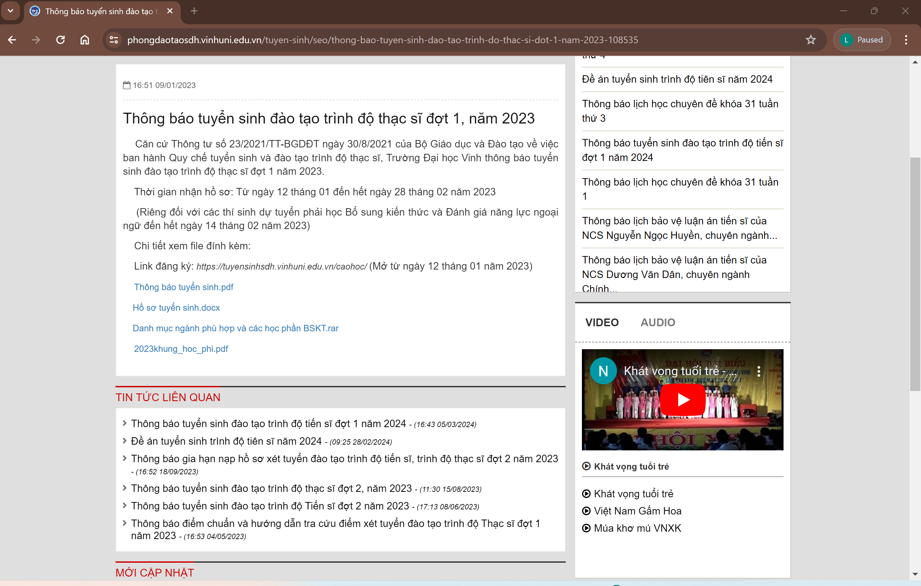
https://vinhuni.edu.vn/thong-bao-tuyen-sinh-dao-tao-trinh-do-thac-si-dot-2-nam-2023-c06.04l0v0p0a129819.html
