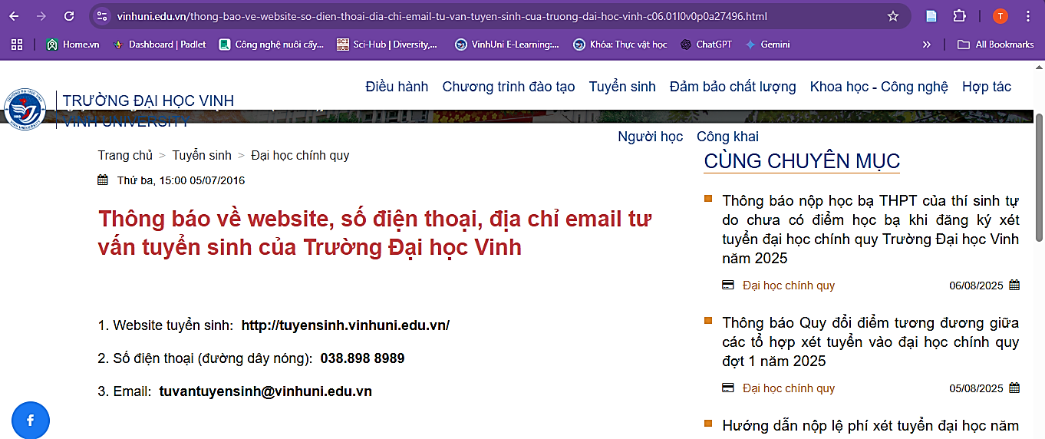
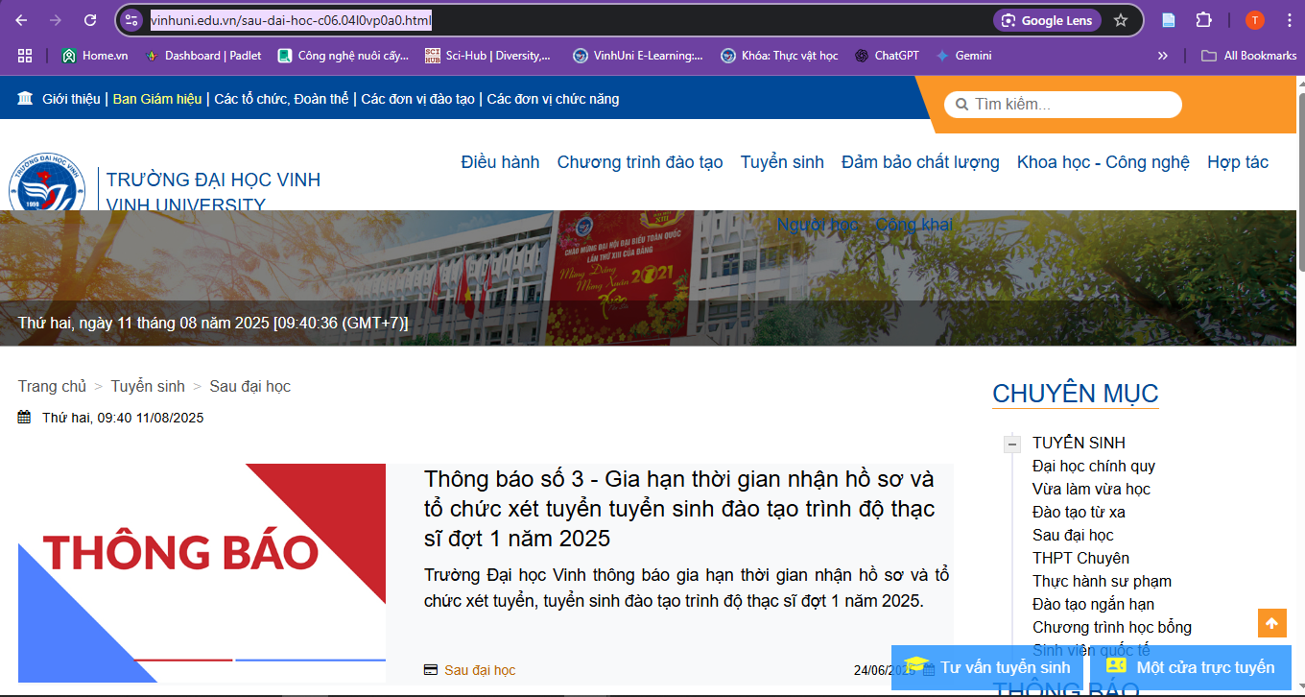
https://www.vinhuni.edu.vn/sau-dai-hoc-c06.04l0vp0a0.html
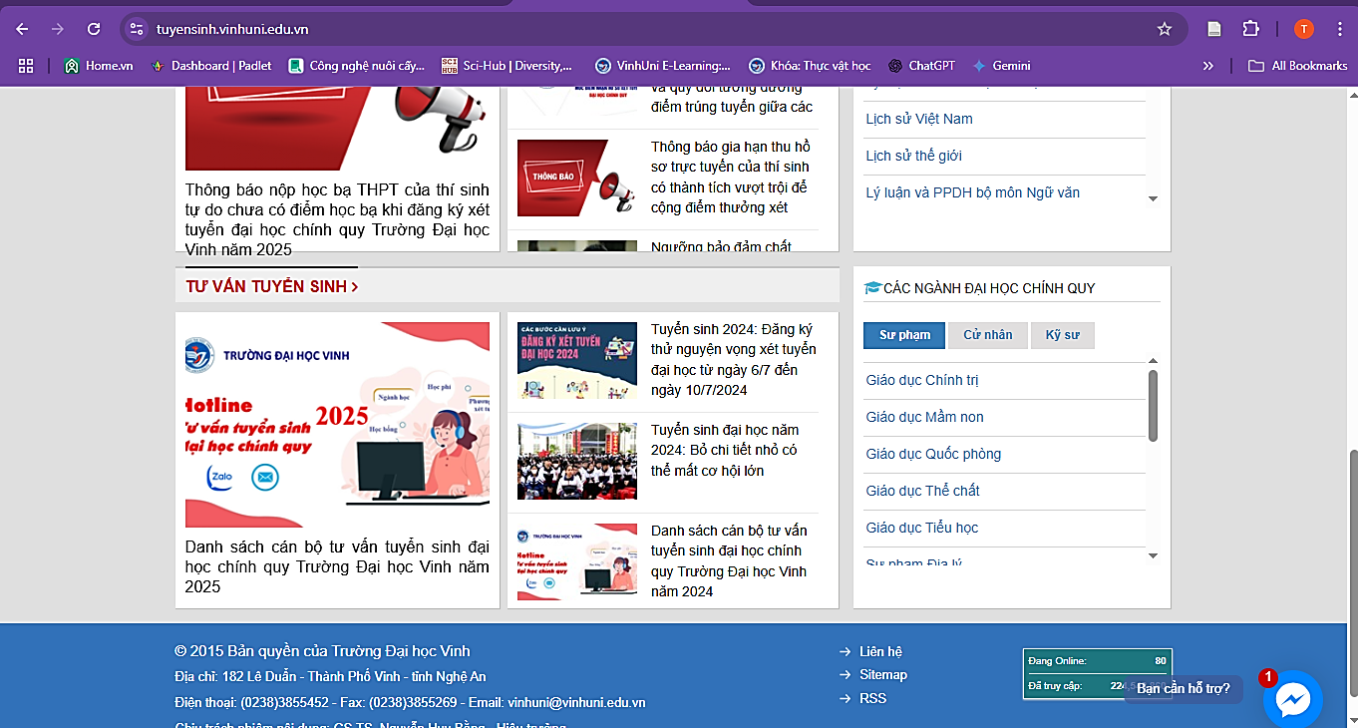
https://tuyensinh.vinhuni.edu.vn/

