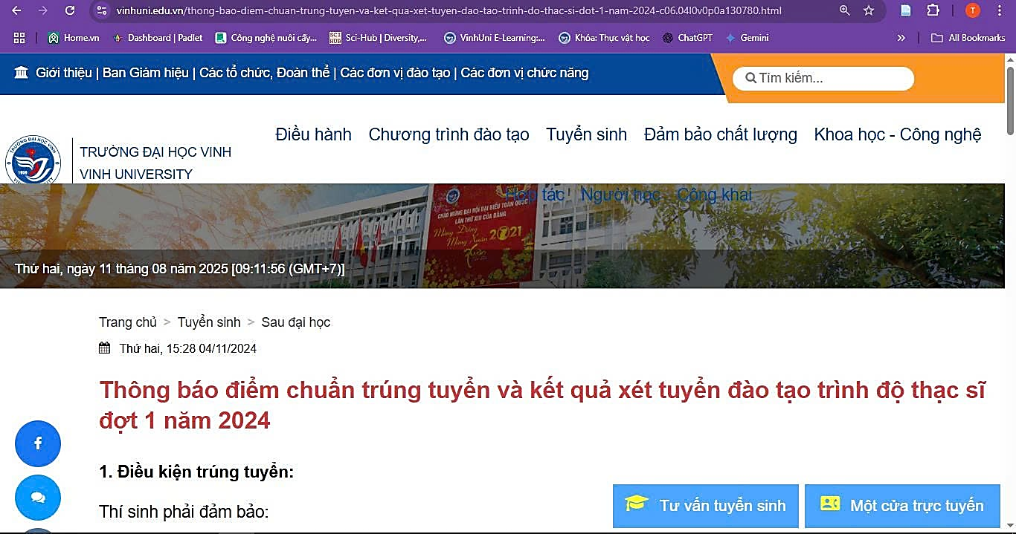
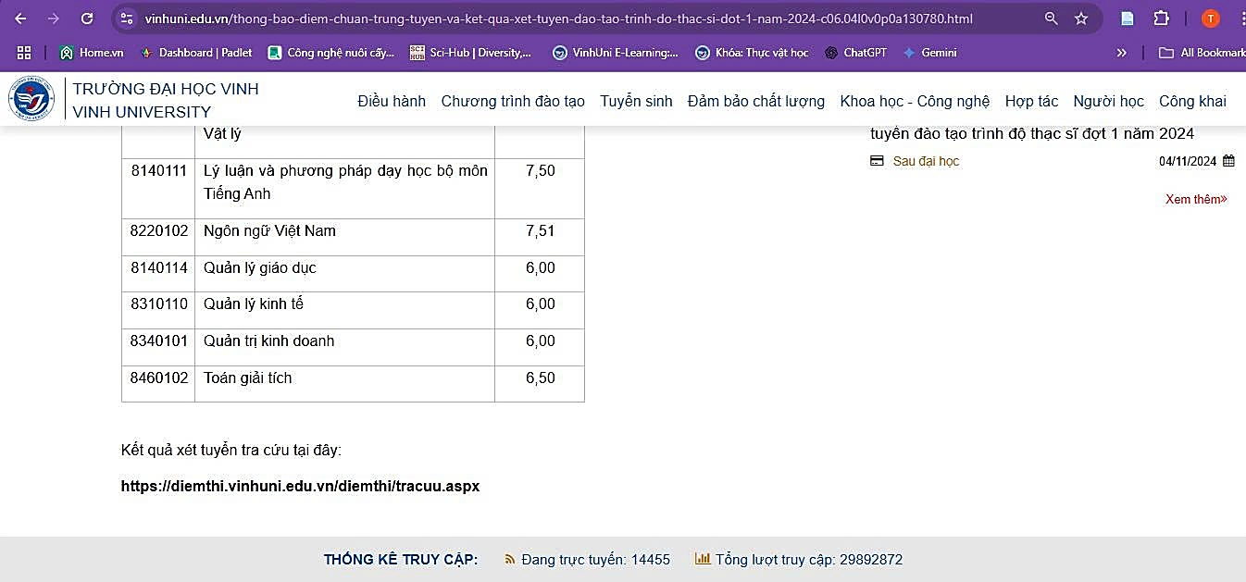
https://vinhuni.edu.vn/sau-dai-hoc-c06.04l0vp0a0.html
https://vinhuni.edu.vn/thong-bao-diem-chuan-trung-tuyen-va-ket-qua-xet-tuyen-dao-tao-trinh-do-thac-si-dot-1-nam-2024-c06.04l0v0p0a130780.html

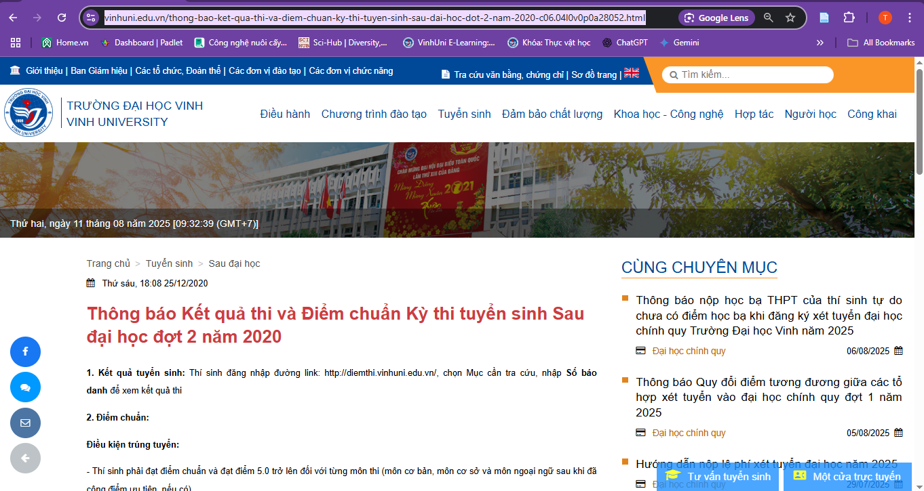

https://vinhuni.edu.vn/trang-so-7-c06.04l0vp7a0.html
https://vinhuni.edu.vn/thong-bao-ket-qua-thi-va-diem-chuan-ky-thi-tuyen-sinh-sau-dai-hoc-dot-2-nam-2020-c06.04l0v0p0a28052.html

