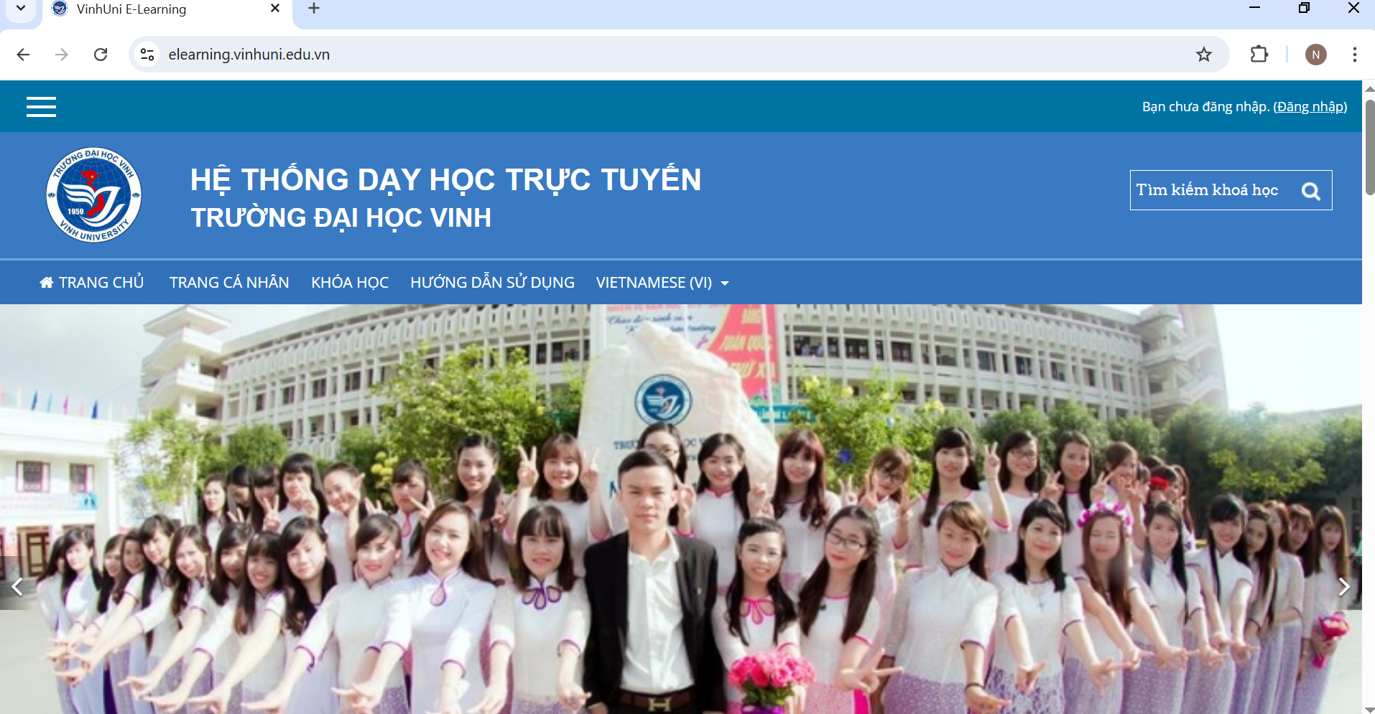

https://elearning.vinhuni.edu.vn/

