Website Khoa Du lịch & CTXH
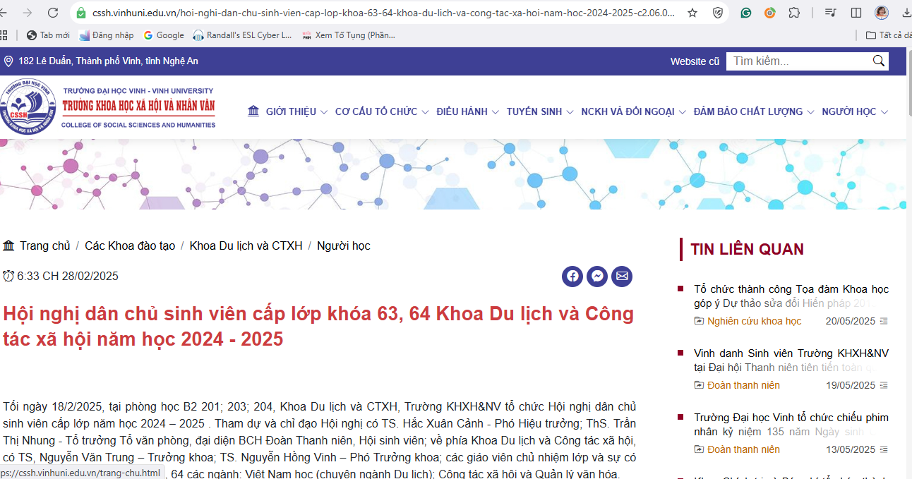

https://cssh.vinhuni.edu.vn/hoi-nghi-dan-chu-sinh-vien-cap-lop-khoa-63-64-khoa-du-lich-va-cong-tac-xa-hoi-nam-hoc-2024-2025-c2.06.03.05l0v0p0a101185.html
