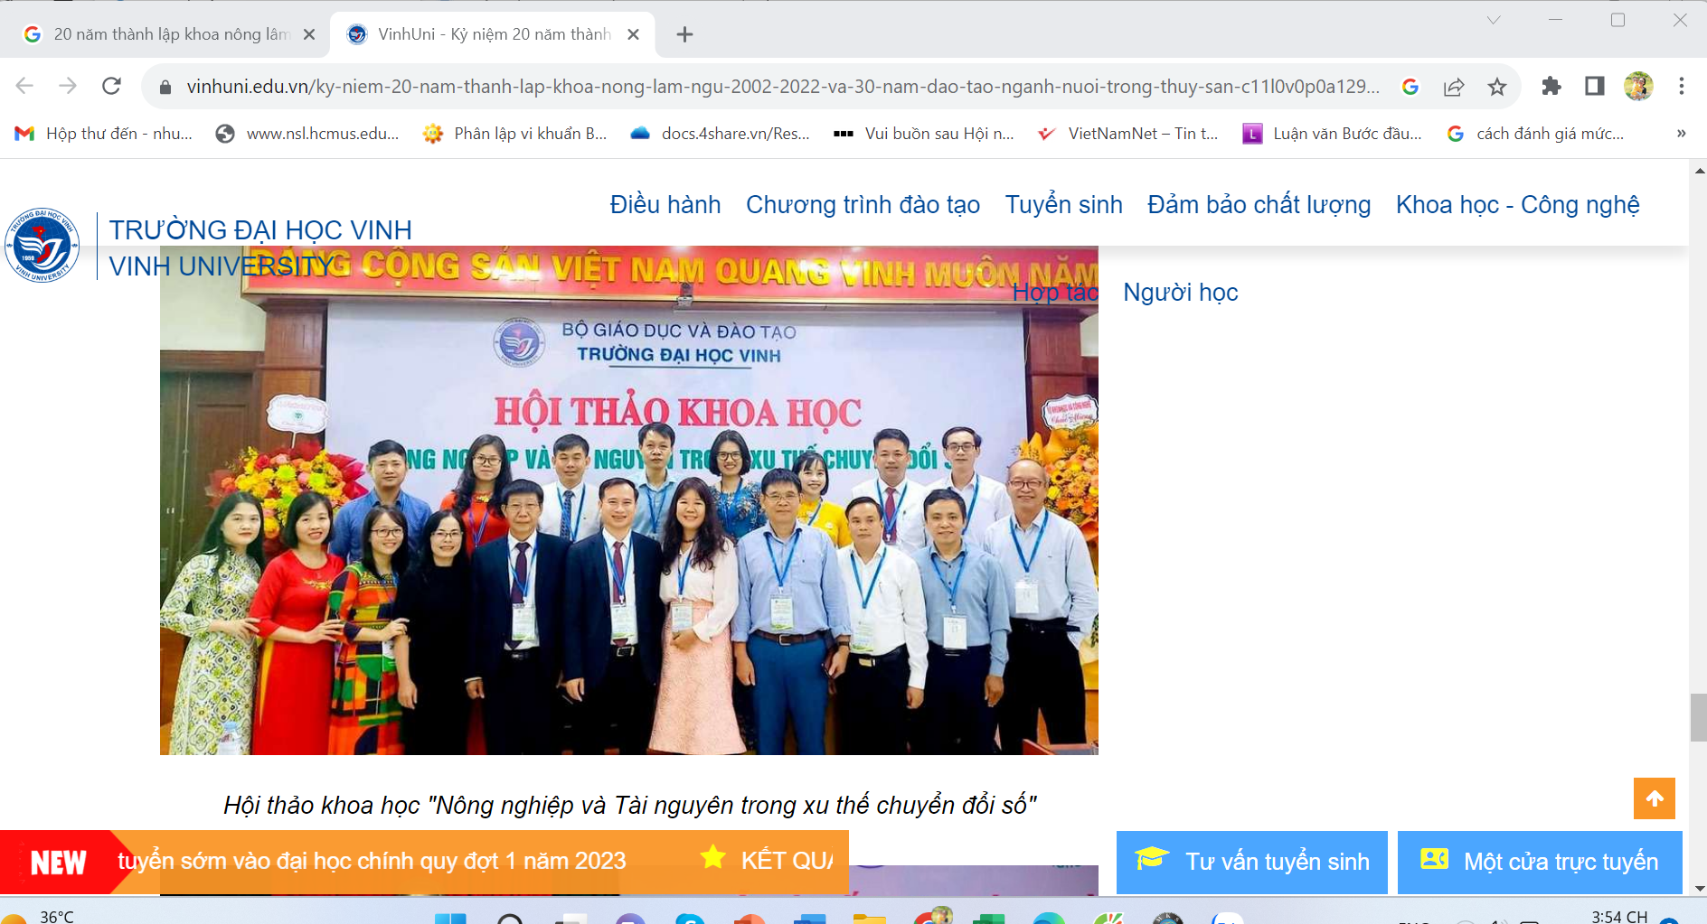
https://vinhuni.edu.vn/ky-niem-20-nam-thanh-lap-khoa-nong-lam-ngu-2002-2022-va-30-nam-dao-tao-nganh-nuoi-trong-thuy-san-c11l0v0p0a129150.html

