Model of developing teacher training program of Vinh University, Vietnam towards capacity development and meeting output standards
Bang Nguyen Huy, Dieu Nguyen Thanh, Thanh Nguyen Thi Trang, Huong Pham Thi and Yen Hoang Phan Hai*
Vinh university, Vietnam
*Email: hoangphanhaiyen@vinhuni.edu.vn
Abstract
Purpose - The purpose of this study is to explore the model of teacher training program development at Vinh University, Vietnam in the direction of capacity development and meeting output standards.
Design/Methodology/Approach - The research employs a qualitative approach, utilizing analysis, evaluation, surveys, and benchmarking to clarify the underlying principles and components of the model. It assesses the strengths and limitations of the model, as well as proposing solutions for its enhancement.
Findings - The findings indicate that Vinh University’s TEP development model effectively addresses gaps in curriculum development that many other universities in Vietnam are currently facing. However, the model also necessitates future adjustments and improvements to sustain its effectiveness.
Originality/Value - This study contributes to the body of knowledge on curriculum development in higher education by presenting a comprehensive model based on the PDCA cycle (Plan-Do-Check-Act), highlighting its applicability in the context of teacher education in Vietnam.
Keywords Training program, teacher training, training based on competencies and output standards, teachers.
Paper type Research paper
1. Introduction
Curriculum development is a core element of a university to improve the quality of education and meet social needs. This is the process of innovating and perfecting the content, teaching methods and assessment methods to ensure that the curriculum is consistent with the development trends of science, technology and professional practice. Curriculum development not only helps students access new knowledge and skills, but also contributes to building high-quality human resources to meet the needs of the labor market. In addition, this process also promotes the research and creativity of lecturers and students, creating a foundation for the sustainable development of the school.
Currently, the trend of developing university training programs is influenced by many factors, including the development of science and technology, the needs of the labor market, and the needs of society in the context of globalization. Therefore, diversity and flexibility, digital technology integration, vocational skills orientation, international integration, sustainable development and social responsibility, and personalized learning are the trends in developing training programs in most universities around the world.
Also in that trend, training program development is carried out according to the PDCA cycle consisting of 4 stages: (1) P-Plan: Develop training program; (2): D-Do: Implement training program; (3) C-Check: Evaluate training program; (4) A-ACT: Improve training program (Shewhart, W. A.1939). This cycle takes place continuously over time and the new always replaces the old to create a new cycle.
In Vietnam, the development of university training programs is regulated in many State documents such as the Law on Higher Education (National Assembly of the Socialist Republic of Vietnam. 2012), the Law amending and supplementing a number of articles of the Law on Higher Education (National Assembly of the Socialist Republic of Vietnam. 2018), Circular 04/2016 (Ministry of Education and Training of Vietnam. 2016), Circular 17/2021 (Ministry of Education and Training of Vietnam. 2021) and many other documents issued by the Government, Ministry of Education and Training of Vietnam. These regulations aim to complete and guide higher education institutions in developing training programs. Currently, the implementation of training program quality assessment according to domestic standards or international standards is a mandatory requirement of Vietnam for higher education institutions.
After analyzing the results of the quality assessment of training programs according to Circular 04/2016 of the Ministry of Education and Training of Vietnam (Ministry of Education and Training of Vietnam. 2016), we found that by February 2024, Vietnam had 1,172 university-level training programs assessed according to the set of standards specified in this Circular. Of the 11 standards and 50 criteria specified in this Circular, 76% of the training programs did not meet the requirements of criterion 5.3 of standard 5, which refers to the assessment of learning outcomes according to output standards, and 79% of the training programs did not meet the requirements of criterion 3.2 of standard 3, which refers to the contribution of courses to output standards. This result demonstrated that the training programs of higher education institutions had the following shortfalls:
Table 1. Shortfalls in the training programs at universities
Shortfalls | Reason | Consequences
1. Unclear career development goals | - Lack of professional competency model  - No relationship has been established between competencies and output standards | Lack of information to perform step 4 in the PDCA cycle mentioned above
2. The contribution of the course to the Program Learning Outcomes (PLO) is unclear | - Lack of model for assigning PLO to Course Learning Outcomes (CLO)  - The model of the correlation between output standards - content and teaching methods - assessment and evaluation is not clear. | The implementation of the teaching process is not consistent with the PLO (step 2 in the PDCA cycle)
3. The achievement level of the learning outcomes cannot yet be assessed | - Lack of standard output assessment model  - Lack of learning outcome assessment model | Learning outcomes have not been assessed according to output standards (step 3 in the PDCA cycle)
Source: Conclusions drawn by the research team from the analysis of quality assessment results of 1,172 university-level training programs assessed for quality according to domestic standards and the results of in-depth interviews with 20 lecturers from 7 teacher training universities in Vietnam and 20 education experts in Vietnam.
The above mentioned shortfalls will lead to difficulties for higher education institutions in meeting Vietnam's regulations:
- “Assessment of learners' learning outcomes must be based on output standards, and must clarify the level of achievement of learners according to the thinking levels specified in the output standards of each subject, each component and training program" (Ministry of Education and Training of Vietnam. 2021)
- Recognition of graduation and granting of graduation certificates: “Accumulating enough credits and completing other required content according to the requirements of the training program, meeting the output standards of the training program” (Ministry of Education and Training of Vietnam. 2021). This leads to the risk of lack of information on meeting the PLO when considering graduation (starting from 2025)
- Lecturers and learners lack information about the level of achievement of CLO to improve teaching and learning activities.
- Employers lack information about students' competency profiles when using students' graduation profiles for recruitment evaluation.
When identifying those shortfalls, Vinh University has had many solutions to overcome them. One of the successes in our research is to build a model to develop a teacher training program based on competency orientation and meeting output standards.
2. Literature review
Developing training programs based on student competency development is a global educational trend, attracting the attention of many researchers and higher education institutions. Studies around the world on this topic have shown a fundamental change in the way training programs are designed and implemented, from focusing on purely academic content to developing specific student competencies to meet the needs of society and the labor market.
Competency development theory originated in the 1970s in developed countries such as the United States, Canada and Australia. At this time, education was driven by the need to develop human resources capable of meeting the demands of the labor market. Early studies, such as McClelland's (McClelland, D. C. 1973), emphasized that competence was a determinant of career success, and therefore, higher education needed to design training programs based on the competencies that students needed to succeed in their future jobs.
In the 1990s and early 2000s, European countries began to pay attention to the development of educational programs oriented towards the development of competencies. One of the important events was the implementation of the Bologna Process (European Ministers of Education.1999), in which European universities committed to aligning their training programs to promote integration and recognition of degrees between countries. Competences became one of the core elements for program evaluation and development, with the goal of ensuring that graduates are globally competitive. The studies of Le Boterf (Le Boterf, G. 2000) and the Tuning Project (González, J., & Wagenaar, R. 2003) played an important role in identifying and systematizing the necessary competencies for students in many different fields.
In recent years, research on competency-based curriculum development has shifted to how to effectively apply this model in different contexts. In developing countries, such as in Asia and Africa, researchers such as Nguyen (Nguyen, Q. T. 2014) and Ssekakubo (Ssekakubo, M. 2020) have considered this approach in developing training programs to improve the quality of higher education and enhance the relevance to the global labor market. Current competency-based curriculum development models not only focus on professional knowledge, but also emphasize soft skills, problem-solving ability and critical thinking. Therefore, in order to develop the capacity of students after graduating from the training program, universities need to identify clear, measurable and assessable output standards.
Contemporary research continues to focus on how to optimize student assessment and personalize learning experiences. New educational technologies, such as data-driven learning and artificial intelligence, are being integrated to track student progress and tailor instruction to individual needs. However, challenges such as cultural differences, limited resources, and the sustainability of competency-based programs remain.
Teacher education programs have changed significantly to meet educational needs and global trends. According to Darling-Hammond (Darling-Hammond, L. 2006), an effective teacher education program requires a combination of theoretical knowledge and practical skills. Countries such as Finland and Singapore are considered to be very effective and high quality because their teacher education programs focus on preparing teachers with comprehensive skills and competencies, especially they have professional mentoring and development systems (Sahlberg, P. 2011). These systems often focus on high teacher selection standards, rigorous academic training programs, and a close connection between theory and practice, helping to produce teachers who are both professionally knowledgeable and adaptable.
Cochran-Smith and Zeichner's (Cochran-Smith, et al. 2005) study emphasized the importance of critical thinking practices in teacher education. Critical thinking allows future teachers to evaluate their teaching methods from multiple perspectives and adapt their practices to meet the diverse needs of their classrooms. Furthermore, Shulman (Shulman, L. S. 1986) introduced the concept of "pedagogical content knowledge", emphasizing that effective teaching depends not only on mastery of subject knowledge but also on the ability to effectively communicate that knowledge to students.
The Vietnamese education system has undergone significant reforms over the past few decades, especially in the area of ​​teacher education. According to Hoa, T.P.N. (Hoa, T.P.N. 2018), teacher education in Vietnam has gradually shifted to a learner-centered approach, in line with the Ministry of Education and Training’s goal of improving educational outcomes nationwide. However, challenges remain in bridging the gap between theory and practice, as many teacher education programs still rely heavily on traditional teaching methods (Nguyen, T. 2017).
Another study by Huong, T.T.P (Huong, T.T.P. 2020) emphasized the need to integrate more practice opportunities in teacher training programs in Vietnam. This includes increasing collaboration between universities and local schools to provide students with practical teaching experience. In addition, modernizing the curriculum to incorporate more interactive teaching strategies and the use of technology can help better prepare future teachers for the modern classroom context.
Circular 17/2021/TT-BGDDT of the Ministry of Education and Training of Vietnam stipulates that the development of university training programs must clearly state the expectations of educational institutions on the capacity and career prospects of graduates of the training program. Therefore, the teaching method must be designed according to a learner-centered approach and the subject of the training process, promoting learners to be proactive and make efforts to participate in learning activities; effectively orienting learners to achieve the CLO, each component and the entire training program. The requirements for PLO are also specified in the Vietnam National Qualifications Framework (Ministry of Education and Training of Vietnam. 2021), which stipulates that graduates of the training course must have knowledge, skills and a level of autonomy and responsibility according to each level of education.
Vinh University, one of the leading teacher training institutions in Vietnam, has made significant efforts to modernize its training programs. Recent improvements in the training program aim to enhance both the academic and professional competencies of teacher education students. The University has adopted a competency-based approach, focusing on equipping future teachers with the necessary skills to manage classrooms, plan lessons, and assess students effectively, and more importantly, changes in the way learning is assessed to achieve the learning outcomes of learners in the training program (Vinh University. 2023). In addition, the University has focused more on practical training through internships and cooperation with local high schools. This is in line with the global trend in teacher education, where experiential learning and the application of pedagogical knowledge in real-life contexts are essential to develop professional competence (Korthagen, F. A. J. 2004). However, Dang (Dang, T. 2019) argues that there is still a need for more continuous professional development opportunities for teacher education students after graduation, ensuring that they remain relevant and responsive to the changing educational needs in Vietnam.
Despite progress in curriculum development at Vinh University, challenges remain. These include limited resources, the need for more faculty with international teaching experience, and the challenge of balancing theoretical knowledge and practical skills. However, there are opportunities from increased government support for educational reforms and international collaborations with foreign universities.
3. Materials and methodology
3.1. Materials
Data for this study were collected from a variety of sources to ensure comprehensive and reliable content analysis. The main data sources include:
- Requirements for assessing the quality of training programs according to the standards of international education quality accreditation organizations such as: FIBAA, AQAS, ASIIN, AUN-QA, ACQUIN, THE-ICE, ACBSP, ABET. These organizations operate in Vietnam under the approval of the Ministry of Education and Training, helping universities in Vietnam ensure quality that meets international standards. These organizations play an important role in promoting educational innovation, developing training programs and enhancing the competitiveness of Vietnamese universities globally.
- The CDIO model (Conceiving - Designing - Implementing – Operating) of curriculum development was initiated by the United States and some European countries (Crawley, E. F., at al. 2014).
- Data on teacher competency frameworks of Southeast Asia (SEAMEO INNOTECH. 2010), Asia Pacific (UNESCO. 2016), California (California Commission on Teacher Credentialing. 2016), Canada (Canadian Teachers’ Federation. 2017).
- Legal documents, regulations and guidelines on training program development of the Prime Minister, the Ministry of Education and Training of Vietnam and the Ministry of Standards for Quality Assessment of Training Programs are stipulated in Circular 04/2016/TT-BGDDT (Ministry of Education and Training of Vietnam. 2016).
- Internal data sources of Vinh University related to the teacher training program such as the regulations of the University; Data on assessment of learning outcomes according to the output standards of the University's teacher training program; Research products from key school-level research topics: Building a quality assurance framework for the teacher training program implemented in 2023.
3.2. Methodology
3.2.1. Data collection
To collect data for determining the teacher training model, we implemented this method in the following order:
- We used a questionnaire designed and distributed to 50 lecturers participating in teaching the teacher training program of Vinh University, to 50 teachers teaching in high schools in Nghe An province to collect information about their views on the current training program, the required competencies and the output standards of the teacher training program. The results included 100 response forms with all the necessary information.
- We conducted in-depth interviews with 20 prestigious and experienced lecturers in teacher training programs at 07 key pedagogical universities in Vietnam and 20 other education experts nationwide to obtain information on the process of designing, implementing and adjusting teacher training programs.
- We conducted an analysis of relevant documents on the output standards of teacher training programs and documents guiding the development of training programs oriented towards competency development (Prime Minister of Vietnam. 2016, Crawley, E. F., at al. 2014, Ministry of Education and Training. 2018).
3.2.2. Data analysis
In this method, we analyze quantitatively and qualitatively.
- For quantitative analysis: We use specialized software in processing survey results, SPSS, to create survey results tables as desired, helping to identify general trends and relationships between factors in the training program.
- For qualitative analysis: We use content analysis to analyze data from interviews and related documents to draw conclusions about the level of meeting output standards and professional capacity of teacher training students after graduation.
3.2.3. Research process
- Step 1: Collect and synthesize documents related to teacher training models and output standards.
- Step 2: Design and publish survey questionnaires, conduct interviews.
- Step 3: Analyze survey and interview data, synthesize findings.
- Step 4: Evaluate and build a model for developing teacher training programs towards capacity development and meeting output standards.
3.2.4. Reliability and validity of research
- Reliability: To ensure the reliability of the study, we conducted a pilot test of the questionnaire before the official implementation, and used the data coding method in qualitative analysis.
- Research value: The study provides a comprehensive view of the teacher training program development model, thereby building and developing the teacher training program of Vinh University to improve the quality of teacher training, meeting the requirements of output standards and professional capacity in the context of modern education.
4. Results
4.1. Model design process
The model design process is researched and implemented by us through the following steps:
Step 1. Determine the design principle

Figure 1. Process of designing training program development model towards capacity development and meeting output standards
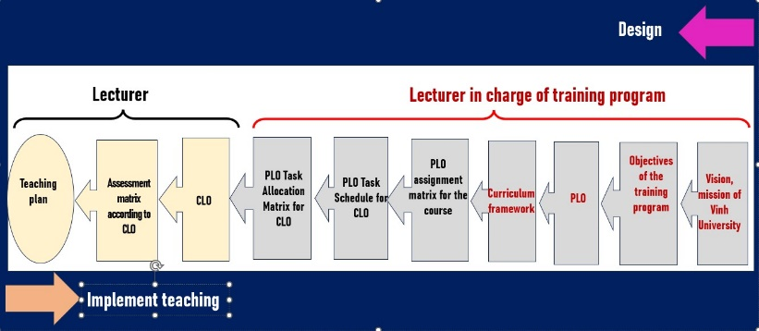
Source: Authors' construct
This model is designed according to the principle of reverse design and the principle of directional compatibility. The starting point in designing the training program originates from social needs, then gradually narrows down to the needs of stakeholders who have direct contact with the training program such as former learners, employers, agencies and departments related to the training field, combined with analysis from internal stakeholders such as faculties/departments to link with the training orientation of the School. Next, these needs will be transformed into the mission of the School of faculties/departments and conveyed into training objectives and learning outcomes at different levels in the training program. Directional compatibility is reflected in the teaching program with compatibility between teaching - learning - testing and assessment activities, designing these activities based on learning outcomes to link the entire learning process through designing oriented learning activities to help learners gradually achieve the declared learning outcomes.
Step 2. Competency framework design
Figure 2. Competency framework of training program
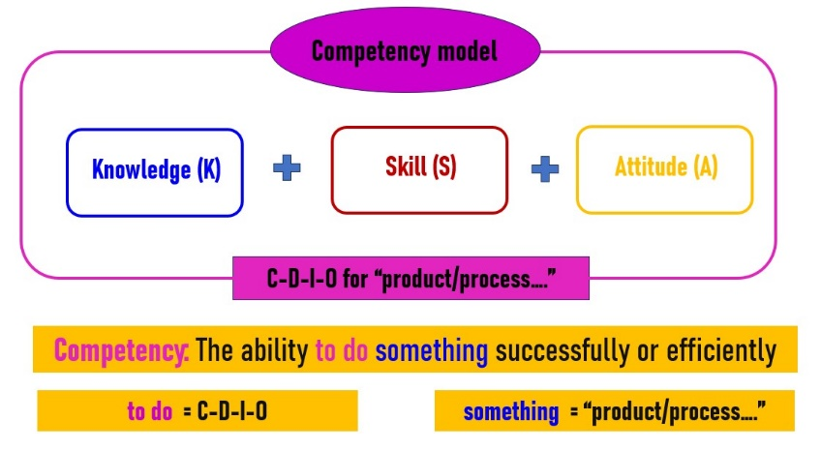
Source: Authors' construct
This competency framework includes knowledge (K), skills (S) and attitudes (A) domains to indicate each output standard area and follows the CDIO process (Conceive - Design - Implement - Operate). (Crawley, E. F., at al. 2014).
Step 3. Building the competency framework of the teacher training program
In this step, we identify the core competencies of teacher training students, which are expressed through competency components, from which we determine the output standards of the training program. Below is the competency framework and PLO that we designed:
Table 2. Competency framework of graduates of teacher training programs at Vinh University
Competency | Competency Indicators
1. Teaching and education | 1.1. Apply specialized knowledge and educational science into professional practice
1. Teaching and education | 1.2. Responsible, dedicated, fair in professional activities.
1. Teaching and education | 1.3. Demonstrates systematic thinking, critical thinking, problem solving skills and creativity.
1. Teaching and education | 1.4. Use teaching and education methods, test and evaluate to develop learners' qualities and abilities.
1. Teaching and education | 1.5. Analyze social and professional contexts and identify learners.
1. Teaching and education | 1.6. Design and organize teaching and educational activities to meet set goals.
1. Teaching and education | 1.7. Develop subject programs appropriate to learners and local realities.
2. Cooperation and management | 2.1. Use communication and cooperation skills in learning and professional activities.
2. Cooperation and management | 2.2. Organize and develop teams, manage and operate professional activities
2. Cooperation and management | 2.3. Consulting and supporting learners in their career activities; building a learning environment and school culture.
2. Cooperation and management | 2.4. Develop relationships with social organizations, teachers, learners, etc. to promote professional activities and scientific research.
3. Professional and career development | 3.1. Demonstrate scientific style, civilized and polite communication attitude and behavior.
3. Professional and career development | 3.2. Self-study, self-improvement, research to improve professional qualifications and pedagogical skills.
3. Professional and career development | 3.3. Using technology, digital transformation in professional activities and scientific research.
3. Professional and career development | 3.4. Able to use foreign languages ​​in communication, study and research.
3. Professional and career development | 3.5. Implement research topics related to training majors and professional practices.
3. Professional and career development | 3.6. Transmit, disseminate knowledge, disseminate research results
3. Professional and career development | 3.7. Coordinate, support and guide others in performing professional duties.
Source: Authors' construct
From Table 1 we design the PLO in Table 2. At the same time, these output standards set in the context of Conceiving - Designing - Implementing - Operating (CDIO) real-world systems and products (Crawley, E. F., at al. 2014).
Table 3. PLO of Vinh University
 | Output standards
1. Fundamental knowledge and reasoning | 1.1.1. Apply basic knowledge of social sciences, politics and law | 4. Conceiving, designing, implementing, evaluate teaching, educational activities and scientific research | 4.1.1. Analyze the social and professional context in teaching, education and scientific research
1. Fundamental knowledge and reasoning | 1.1.2. Apply basic and specialized scientific knowledge of the training industry
1. Fundamental knowledge and reasoning | 1.1.3. Apply knowledge of educational science, theory and teaching methods of teacher training subjects
2. Personal and professional skills and attributes | 2.1.1. Demonstrate critical thinking, systematic thinking, problem solving skills and creativity |  | 4.2.1. Propose topics in teaching and education, scientific research
2. Personal and professional skills and attributes | 2.1.2. Use technology and digital transformation skills in teaching, education and scientific research
2. Personal and professional skills and attributes | 2.1.3. Use teaching and educational skills |  | 4.2.2. Design teaching and education plans, scientific research
2. Personal and professional skills and attributes | 2.1.4. Use specialized scientific research skills and educational science
2. Personal and professional skills and attributes | 2.1.5. Demonstrate self-learning skills, self-control and adaptability to changes
2. Personal and professional skills and attributes | 2.1.6. Demonstrate ethics and teaching style |  | 4.2.3. Implement teaching, education and scientific research activities.
3. Skills: Teamwork and communication | 3.1.1. Demonstrate teamwork skills in learning, teaching and educational activities, and scientific research.
3. Skills: Teamwork and communication | 3.2.1. Use forms of communication in learning, teaching and educational activities, and scientific research. |  | 4.2.4. Evaluate teaching and educational activities, scientific research
3. Skills: Teamwork and communication | 3.2.2. Able to use foreign languages ​​(level 3/6) in communication, teaching and educational activities, and scientific research
Source: Authors' construct
The outstanding advantage of CDIO is to provide a complete set of tools for building PLO, designing and implementing teaching programs, developing resources to ensure training program operations and evaluating training program improvements in a closed cycle. What is more interesting is that CDIO is completely compatible with the widely used P-D-C-A quality improvement cycle. Thus, CDIO standards focus on comprehensively developing the necessary competencies and skills of students to quickly adapt to the working environment, meet the needs of employers, thereby helping to narrow the gap between school training and social requirements.
Step 4. Design a scale to measure the training program's output standards
Figure 3. Standard output scale of training program
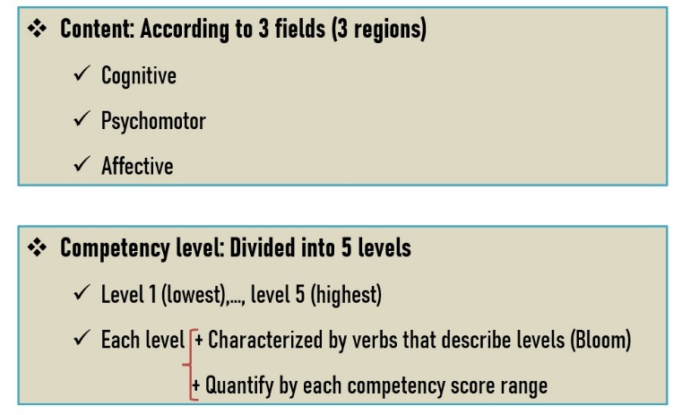
Source: Authors' construct
This scale is determined by the content of the output standards in three areas: cognitive - psychomotor/skills - emotional/attitude. In this scale, we specify the level of competence from 1 to 5, in which level 1 is the lowest, level 5 is the highest. Each level is represented by verbs according to Bloom (Anderson, L. W., et al. 2001) and is quantified according to each range of competence scores.
Table 4. Competency levels, competency scores and competency level descriptions of PLO
Competency level | Competency level score | Description of output standard competency levels  in 3 areas
Competency level | Competency level score | Knowledge (K) | Skill (S) | Attitude (A)
Level 5 | 4,5 – 5,0 | Creating | Origination | Characterization
Level 4 | 3,5 – 4,4 | Analyzing, Evaluating | Adaptation | Organization
Level 3 | 2,5 – 3,4 | Applying | Precision | Valuing
Level 2 | 1,5 – 2,4 | Understanding | Manipulation | Responding
Level 1 | 0,5 – 1,4 | Remembering | Perception | Receiving
Source: Authors' construct
Step 5. Design a teaching program compatible with output standards
Figure 4. Curriculum design model
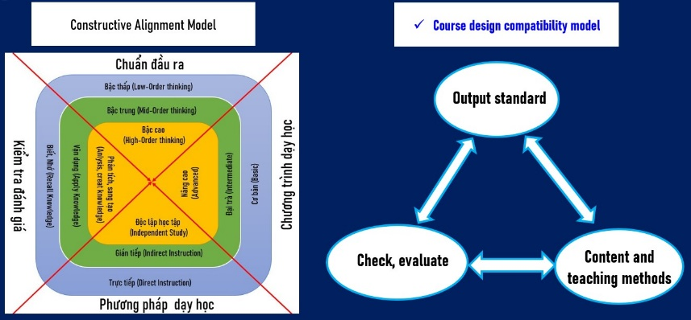
Source: Authors' construct
The curriculum is designed according to the Constructive Alignment Model (Biggs, J., et al. 2011), the reverse design process and the CDIO-Flipped-Blended Learning model.
- The curriculum is designed according to the advanced level of constructivist compatibility model, corresponding to the output standards at competency levels 4 and 5; active teaching methods, independent research; assessment activities towards creative products. To ensure this compatibility, we focus on implementing the project-based learning method (PBL), with a minimum weight of 25% of the total credits in the entire program.
- Reverse design process: the training program design process starts from the training PLO, then implements the design in the following order: Training program framework - Assign training program output standards to modules - Determine CLO - Evaluate according to the CLO matrix - Teaching plan according to the evaluation matrix.
- The CFB model (CDIO-Flipped-Blended Learning) is an integrated model between the models: CDIO - Flipped Learning - Blended Learning. In which:
+ The CDIO model is associated with the construction of PLO according to 4 pillars according to the CDIO outline (knowledge, professional skills, communication and teamwork, CDIO capacity) and 12 CDIO standards on training program development and operation.
+ Flipped learning focuses on designing learning activities into two parts: self-study and classroom learning. The self-study part is implemented before class and is associated with theoretical learning corresponding to low-level competency requirements (levels 1, 2, 3), while the classroom learning part is implemented after the self-study part and is used for activities to practice high-level skills and cognition (levels 4, 5).
+ Blended learning focuses on designing teaching activities into two parts: online and face-to-face.
Under this model, the teaching and learning activities are designed so that the self-study part is implemented through electronic learning materials on the learning management system (LMS). The direct learning part will be implemented directly in the classroom, laboratory or real-life experience. In some specific cases, the CFB model will be transformed into the CFO model, where the direct teaching part is implemented online through the Teams application, Zoom or another simultaneous online teaching application.
Step 6. Design a matrix to assign training PLO to CLO
Figure 5. Assignment of PLO to CLO
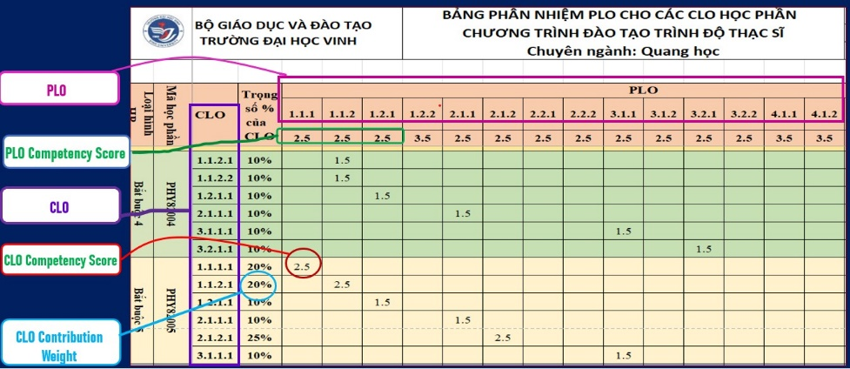
Source: Authors' construct
- Each PLO is assigned to at least 03 subjects and is prioritized to be arranged in different, consecutive semesters;
- Each subject is assigned a maximum of 05 PLO; project-based teaching subjects are assigned a minimum of 06 PLO, ensuring all types of output standards in all 3 areas of knowledge, skills and attitudes; the number of PLO assigned to each subject is the basis for assigning credits to the subject.
- When a PLO is assigned to subjects, the competency level of that PLO in each subject may be different (according to the competency score). However, the competency level value of each subject must be designed so that when taking the average (according to the subject weight) of all assigned subjects, it will equal the competency value of the PLO. (The weight of the course is calculated based on the ratio of the number of credits of the assigned course to the total number of credits of all courses assigned to that output standard and is calculated as a percentage after rounding to an integer).
- The minimum competency level of each PLO is level 3 (corresponding to a minimum competency score of 2.5), the weight of the course assigned to the PLO must reach at least 30% of the competency level from level 4 or higher.
- For PLO in the skill or attitude domain, the competency level is designed to increase gradually over time (semesters) for the assigned courses in the teaching program framework.
Step 7. Design the assessment competency matrix
Figure 6. Assessment Competency Matrix
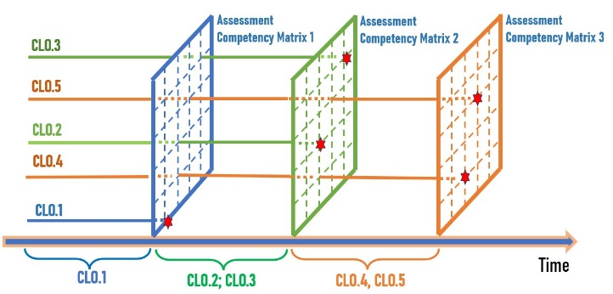
Source: Authors' construct
- Learner assessment methods are designed based on the output standards.
- Measurement and assessment of the level of achievement of output standards are carried out through the topics and competency levels of the output standards.
- Assessment methods and tools are selected appropriately for each type of output standard and the required competency level.
- The requirements for the competency level required for the CLO in the assessment tests and at the end of the course are specified in detail in the course outline. The competency level requirements for the PLO are assigned to the courses and are specified in the table of assignment of PLO for the courses.
- The assessment is designed to the level of competency required for the CLO. The assessment may design some content corresponding to a lower level of competency than the required competency, but the weight of the content corresponding to the required competency must account for at least 60%.
- Learners are recognized as “Achieving” the CLO if they complete at least 50% of the assigned content to assess the required competency level.
- The competency score of an output standard is converted from the completion percentage of each competency level
- When the required competency level does not meet the requirements (the completion percentage of the required level is below 50%), the competency score of the adjacent level below is determined to calculate the competency score of the actual achieved CLO (in a similar way).
- The competency score of a CLO is calculated in the final assessment of that CLO.
- The competency score of the training program assigned to the courses is a combination of CLO that meet the PLO with the weights specified in the detailed outline.
- The competency score of a PLO is a combination of the competency scores of the PLO assigned to the subjects with the weights specified in the output standard assignment table.
Step 8. Develop a teaching plan and implement teaching
Figure 7. Teaching plan and implement teaching
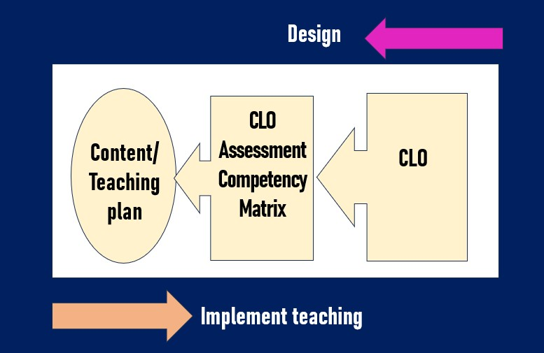
Source: Authors' construct
The development of teaching plans and teaching organization is carried out after the assessment capacity is built to ensure that the implementation of teaching and learning meets the output standards and measures the students' capacity. This is a design approach to ensure compatibility and address the gaps mentioned in the introduction.
5. Discussion
The teacher training program development model of Vinh University has been built on the principle of competency orientation, combined with the requirement to meet output standards. This approach not only meets the requirements of modern education reform but also creates a solid foundation for training teachers who can adapt to the rapidly changing educational context.
First of all, the competency-based model allows for the clear identification of core competencies that teachers need to achieve, from professional and pedagogical competencies to social and personal development competencies. This helps the curriculum development to no longer focus on imparting theoretical knowledge, but instead shift to developing learners’ practical skills and creative thinking. Survey results show that students have significantly improved their ability to self-study, problem-solve, and apply technology in teaching - essential factors to become effective teachers in the context of modern education.
Second, this model also integrates specific output standards, closely following the requirements of the Vietnamese Ministry of Education and Training, while reflecting the practical needs of employers and other stakeholders. The close connection between output standards and training activities not only creates transparency in the training process but also helps schools easily evaluate and adjust the program according to objective criteria.
However, this model also faces some notable challenges. The biggest challenge is to balance ensuring output standards and developing diverse student competencies. In addition, the application of new teaching and assessment methods requires changes in the awareness and skills of lecturers, which takes time and requires support in terms of management and infrastructure. In the coming time, to address these challenges, we have proposed some solutions as follows:
(1) Developing an innovative university ecosystem at Vinh University: is a model of close cooperation between stakeholders such as the university, high schools, management agencies and the community. In this ecosystem, we will develop a project to transform Vinh University into an innovation center. This ecosystem creates conditions to promote creative thinking, apply technology and modern teaching methods to meet the needs of society. By continuously updating knowledge, skills and output standards based on trends and practical requirements, this ecosystem contributes to improving the quality of the teaching staff, meeting international standards and sustainable development.
(2) Developing a teacher training program oriented towards innovation and entrepreneurship includes: (i) developing a teaching model based on output standards on the basis of the CDIO model (Crawley, E. F., at al. 2014); (ii) applying the Pillars of Flipped Learning and the Blended Learning method, both online and face-to-face; (iii) designing a series of project-based teaching subjects in the teacher training program following the competency development path from the first to the fourth year of the course, in which project-based subjects will be assigned to meet 3 types of output standards in the fields of knowledge, skills, attitudes, linked to practice, linked to scientific and technological products, innovation and entrepreneurship.
(3) Developing teachers to become professional teachers: We will train lecturers who directly teach teacher training programs to become people who: (i) have the ability to proactively adapt and develop training programs; (ii) have the ability to be flexible in choosing content, methods and forms of assessment suitable for each student in order to help students maximize their potential, while enhancing autonomy and responsibility in learning; (iii) teachers have the capacity for digital transformation in curriculum development, lesson design and teaching organization; (iiii) they have the ability to conduct scientific research, innovate and start-up; (iiii) build and develop research groups in which there is a close connection between research and training, innovation and start-up.
(4) Creating an innovative infrastructure includes: (i) building a quality management process for teacher training programs according to the International Organization for Standardization (ISO. 2018); (ii) developing an intelligent management platform on the University System for Management and Resource Tracking (USMART) information technology system. This is a system developed to support the management and operation of educational activities at universities, helping to automate educational management processes from student records management, course registration, to teaching quality assessment survey activities; (iii) developing a digital-based learning management system Learning Management System (LMS). This is a learning management system that helps organize and manage online learning and training activities. LMS allows schools to track, manage and distribute courses, documents and learning resources to students and lecturers. This system includes features such as managing lectures, tests, discussion forums and tracking students' learning progress; (iii) investing in building a digital learning materials production center with full functions such as: building and developing teaching materials, textbooks and lectures in digital form, providing platforms and tools for lecturers and students to conduct online teaching and learning, organizing training courses to help lecturers effectively use information technology in teaching, collaborating and sharing educational resources; (iii) developing and perfecting research and development laboratories, where lecturers and students can conduct research, testing and developing new products or technologies. R&D labs often play an important role in training pedagogical students to practice their profession and innovate to create valuable educational products, linking theory and practice.
Finally, the model of developing teacher training programs of Vinh University in the direction of competency and meeting output standards not only creates innovation in educational approaches, but also demonstrates a long-term vision in improving the quality of higher education. Initial results show the effectiveness of this model, but further research is still needed to assess the long-term impact and adjust it to changes in the international educational context.
6. Conclusion
Developing teacher training programs that are oriented towards capacity development and meet output standards is one of the important factors to improve the quality of education. It ensures that students not only master theoretical knowledge but also develop practical skills, critical thinking ability, professional capacity, meeting the requirements of society and the labor market.
In the world, developed countries such as the United States, the United Kingdom, and Australia have successfully implemented training programs in the direction of capacity development. The capacity-based education system is designed so that students can flexibly apply knowledge into practice. In Vietnam, although there have been advances in reforming the education program in this direction, the implementation is still limited in terms of methods and supporting infrastructure.
In many countries, teacher training programs have been redesigned to meet output standards, with a focus on developing teaching skills, creative thinking, and classroom management skills. In Vietnam, the process of reforming teacher training programs has taken place but has been slow. Many schools still focus on teaching theory, while developing practical skills and teaching capacity has not received due attention.
Vinh University has made efforts to innovate the teacher training program towards capacity development and meeting output standards. With a strict construction and improvement process, having a scientific basis and inheriting from teacher training models of advanced countries, during the testing process, this model has helped improve the quality of education, ensuring that students have enough knowledge and skills to become good teachers. This model also helps to enhance students' adaptability to new teaching requirements, while creating a more dynamic and practical learning environment. The results of collecting opinions from 50 lecturers directly teaching the teacher training program showed that teachers and students have changed their teaching and learning methods, teachers are proactive in designing subjects and lessons, students are autonomous and have their individual roles promoted as well as recognized their own values ​​to adapt to the needs of the job market and career. However, implementation still faces many difficulties, including lack of resources, non-innovative teaching methods, and limited ability of students to apply theory to practice. Synchronization in the process of evaluating and improving the program is also not complete.
To develop the training program in this direction, Vinh University needs to invest more in improving the capacity of the teaching staff, improving facilities and applying modern technology in teaching. In addition, there needs to be a mechanism for continuous evaluation and improvement of the program, as well as strengthening cooperation with international schools to learn and apply advanced teaching methods.
Acknowledgements: This study was funded by the Science and Technology Fund of Vinh University for the key school-level project “Building a quality assurance framework for developing a CDIO-based teacher training program at Vinh University”, code T2022-06TĐ.

Conferences
Anderson, L. W., & Krathwohl, D. R. (Eds.). (2001). A taxonomy for learning, teaching, and assessing: A revision of Bloom’s taxonomy of educational objectives. Longman.
Biggs, J., & Tang, C. (2011), Teaching for quality learning at university (4th ed.), McGraw-Hill Education.
California Commission on Teacher Credentialing.(2016), California teaching performance expectations, California Commission on Teacher Credentialing.
Canadian Teachers’ Federation. (2017). Framework for the Teaching Profession. Canadian Teachers’ Federation.
Cochran-Smith, M., & Zeichner, K. M. (2005), Studying Teacher Education: The Report of the AERA Panel on Research and Teacher Education. American Educational Research Association.
Crawley, E. F., Malmqvist, J., Östlund, S., Brodeur, D. R., & Edström, K. (2014). The CDIO Standards 3.0: An updated statement of the goals and methods of the CDIO approach to engineering education. CDIO.
Dang, T. (2019).Developing teacher training programs in Vietnam: Challenges and opportunities. Vietnam Education Publishing House.
Darling-Hammond, L. (2006). Constructing 21st-Century Teacher Education. Journal of Teacher Education, 57(3), 300-314.
European Ministers of Education. (1999), The Bologna Declaration of 19 June 1999. Bologna Process.
González, J., & Wagenaar, R. (2003), Tuning Educational Structures in Europe: Final Report - Phase One, University of Deusto.
Hoa,T.P.N. (2018), Developing teacher training programs based on competency and output standards, Vietnam Education Publishing House.
Huong,T.T.P. (2020). Developing teacher training programs in the context of current educational innovation. Pedagogical University Publishing House.
Korthagen, F. A. J. (2004), In search of the essence of a good teacher: Towards a more holistic approach in teacher education. Teaching and Teacher Education, 20(1), 77-97, https://doi.org/10.1016/j.tate.2003.10.002
Le Boterf, G. (2000), Compétence et navigation professionnelle, Éditions d’Organisation.
McClelland, D. C. (1973), Testing for competence rather than for intelligence. American Psychologist, 28(1), 1-14.
Ministry of Education and Training of Vietnam. (2016), Circular promulgating regulations on standards for assessing the quality of training programs at all levels of higher education, Circular No.: 04/2016/TT-BGDDT.
Ministry of Education and Training. (2018), Circular promulgating the general education program. Circular No.: 32/2018/TT-BGDDT
Ministry of Education and Training of Vietnam. (2021), Circular regulating training program standards, developing, appraising and promulgating training programs for all levels of higher education, Circular No.: 17/2021/TT-BGDDT.
Ministry of Education and Training of Vietnam. (2021), Circular promulgating regulations on university level training, Circular No.: 08/2021/TT-BGDDT.
National Assembly of the Socialist Republic of Vietnam. (2012), Law on Higher Education. Law No.: 08/2012/QH13.
National Assembly of the Socialist Republic of Vietnam. (2018), Law amending and supplementing a number of articles of the Law on Higher Education, Law No: 34/2018/QH14.
Nguyen, Q. T. (2014), Developing competency-based training programs in higher education in Vietnam: Lessons learned from international practices. Vietnam Journal of Education, 1(4), 45-52.
Nguyen, T. (2017). Building teacher training programs to meet the requirements of educational innovation. Vietnam Education Publishing House.
Prime Minister of Vietnam. (2016), Decision approving the national qualification framework of Vietnam. Framework No: 1982/QD-TTg
Sahlberg, P. (2011), Finnish Lessons: What Can the World Learn from Educational Change in Finland? Teachers College Press.
SEAMEO INNOTECH. (2010), Common Southeast Asian teacher competency standards. SEAMEO INNOTECH.
Shewhart, W. A. (1939). Statistical Method from the Viewpoint of Quality Control. The Graduate School, Department of Agriculture, United States.
Shulman, L.S. (1986), Those Who Understand: Knowledge Growth in Teaching. Educational Researcher, 15(2), 4-14.
Ssekakubo, M. (2020). Competency-based education in Sub-Saharan Africa: An analysis of policy and practice. African Journal of Education, 39(3), 32-46.
UNESCO.(2016), Asia-Pacific teacher competency framework for a new vision of education, UNESCO Bangkok.
Vinh University. (2023), Training Program Quality Assurance Standards (Version 1.0), Vinh University Publishing House

Corresponding Author:
Yen Hoang Phan Hai can be contacted at: hoangphanhaiyen@vinhuni.edu.vn

